Keck Adaptive Optics Note 1165

AO Telemetry for PSF-R

Sam Ragland; 3/28/2017

The AO telemetry required for PSF reconstructions for each science exposure are extracted from the wavefront controller and stored as IDL save file. i.e. one telemetry file for each science exposure. The filename has similar nomenclature as the science filename. For instance, the telemetry filename for nirc2 file ‘n0032.fits’ would be either ‘n0032_NGS_trs.sav’ or ‘n0032_LGS_trs.sav’ depending on the mode of operation (NGS or LGS.) The list of all variables in the telemetry file for the LGS case is should below:

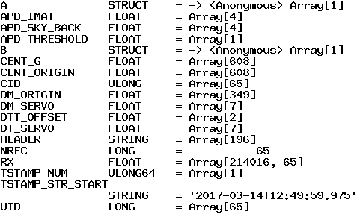

The data structure *A* and *B* are ones holding the time-varying AO control loop telemetry data. The structure *A* holds the WFS data and structure *B* holds the STRAP tip/tilt data essential for the LGS case. Accordingly, the telemetry file for the NGS case won’t have the data structure, *B*. The variables in the data structure *A* are shown below:

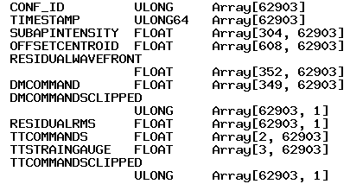

The variables in the data structure *B* are shown below:

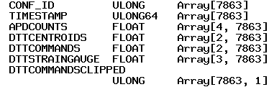

Table 1 shows the list of time-dependent telemetry channels and Table 2 shows the fixed telemetry channels for a given science exposure.

|  |  |  |
| --- | --- | --- |
| **Telemetry Channel Name** | **Description** | **Unit** |
| TIMESTAMP | Relative time.  The A-structure timestamp corresponds to the fast WFS.  The B-structure timestamp corresponds to the TT WFS. | 100 ns  measured “since the beginning of the calendar year” |
| SUBAPINTENSITY | Dark-subtracted and flat field corrected Sub-aperture intensity | adu |
| OFFSETCENTROID | Centroid offset for the 304 sub-apertures: [x1,y1], [x2,y2], …. [x304,y304] | arcsec |
| RESIDUALWAVEFRONT | Residual wavefront.  [0:348,*]: residuals at the 349 actuators  [349:350,*]: residual tip/tilt  [351,*]: residual defocus | Volts (volts-2-micron conversion factor is 0.6 microns/volt)  arcsec  microns |
| DMCOMMAND | DM actuator command | Volts (the volts-2-micron conversion factor is 0.6 microns/volt) |
| TTCOMMANDS | In LGS mode: Laser Tip/tilt actuator command. This is the TT signal coming from the fast, high-order WFS. | arcsec |
| APDCOUNTS | APD counts for the four quadrants. | counts |
| DTTCENTROIDS | Down tip/tilt centroid: [x, y].  This is a measure of the TT residual. | arcsec |
| DTTCOMMANDS | Down tip/tilt actuator command in absolute offsets. | arcsec |

**Table 1: The time-dependent telemetry channels used for PSF reconstructions**

|  |  |  |
| --- | --- | --- |
| **Telemetry channel Name** | **Description** | **Unit** |
| CENT_G | Centroid gain for the 349 actuators |  |
| CENT_ORIGIN | WFS Centroid origin for the 304 sub-apertures: [x1,y1], [x2,y2], …. [x304,y304] | arcsec |
| DM_SERVO | DM servo parameters |  |
| DT_SERVO | Down TT servo parameters |  |
| TSTAMP_STR_START | Start time |  |

Table 2: The time-dependent telemetry channels used for PSF reconstructions

The variable, ‘header’ refers to the NIRC2 science header. A sample NIRC2 science header is given in the Appendix. The sampling rate for the WFS and the STRAP can be different.

There are redundant telemetry data currently stored in the save file. The telemetry list will be revisited at the end of the science verification phase.

# Appendix

